# **THE MOTHER’S FUNDING REQUEST TO THE FORD FOUNDATION**

# **TO BUILD AUROVILLE VIA SYSTEMS ENGINEERING**

*In 1968 the magazine* Scientific American *published a special edition on urban planning; an advertisement by the Planning Research Corporation caught Suresh Hindocha’s attention.[1] His letter was answered by Dr. Sidney Firstman, explaining how new towns could be built with systems engineering in a few years. This was a logical initiative, as in subsequent years the application of systems engineering to the building of new towns became routine. In consultation with the Mother, Suresh and his brother Harish maintained contact with Dr. Firstman, whom they met in Paris, in Roger Anger’s office. Letters were exchanged between them as well with the Mother’s architect, Roger Anger, and her son André, who reported regularly to the Mother.*

*The outcome of Suresh and Harish Hindocha’s efforts, in consultation with the Mother, Roger and André, was that a preliminary master-plan was prepared to submit it to the Ford Foundation for partly financing a feasibility study for Auroville to be built in a few years via systems engineering. On March 13, 1969, as President of the Sri Aurobindo Society the Mother signed the following funding request that Suresh was to submit in person to the Ford Foundation.*

*Paulette*

To: Mr. Douglas Ensminger Auroville Industry, Commerce

The Ford Foundation & Finance Department

55 Lodi Estate, 24 Rue Francois Martin,

New Delhi – 3 P.O. Box 85

India. PONDICHERRY, India.

13th Thursday March 1969

Dear Sir,

Regarding: Proposal for partially funding the application of a systems engineering approach to the planning of Auroville.

Sri Aurobindo Society – an institution recognized by the Council of Scientific and Industrial Research as engaged in research in Social Science – is sponsoring the Auroville Project in South India in order to promote “material and spiritual researches for a living embodiment of an actual human unity”.

Auroville is unique – not only is it a city being constructed from scratch but it combines the social, economic and physical aspects of the city in a manner designed to enhance the evolutionary process in man. As such the 14th General Conference of UNESCO held in Oct-Nov 1966 passed a resolution expressing the belief that the project will contribute to international understanding and promotion of peace, and UNESCO commended this project to those interested in UNESCO’s ideals. Again in Oct-Nov 1968 at the 15th General Conference of UNESCO a resolution was passed calling on Members and non-Governmental Organization to participate in development of this project. For reference copies of the resolution and other material relating to the interest of UNESCO are enclosed.

Meanwhile from the very inception of this project the Government of India has been supporting Sri Aurobindo Society in various ways as set out in the enclosed references. The Government of India has made the project known at home and abroad through official channels. Sri Aurobindo Society apart from being tax exempt, from the Government of India also enjoys various facilities from the Reserve Bank of India such as a blanket no objection authorisation for import of goods/articles and authorisation to open overseas bank accounts. The Ministry of Education has extended a grant for the quarterly publication of Aurovi11e – “*Equals One*” which is Auroville's official publication. At present the Planning Commission is considering what activities can be financed at Auroville in the fields of education and health. However, we are expected to pursue our requests concretely when we have adopted the planning approach proposed in this letter.

It is necessary to outline what little development that has taken place at Auroville at the very onset before introducing – why we at Auroville have decided to apply the systems engineering approach, to the Planning of Auroville what this approach involves with respect to town planning, what type of development organisation and personnel may be required, and where in the above context may be possible for the Ford Foundation to supplement Auroville’s efforts in this direction.

Until now most of the work of Auroville has been of a preparatory nature. Some 1,500 of the l0,000 acres of land required initially have been acquired though not contiguously. On this land agricultural activity has already started quite successfully a model agricultural village named “*Hope*” is under construction. Deep-bore welling to raise the area’s water resources has been successful a1so. Construction has been taking place mainly at “*Promesse*” where Aurovilians working at site are accommodated, meanwhile a guest-house is also nearing completion there.

For the coming three years it is expected that major construction at "*Auromodel*" will be implemented in four phases. In so far as this advanced colony will represent most of the major facets of Auroville it will provide a great deal of planning data for Auroville proper.

Meanwhile some of the preliminary ideas and planning so far accomplished are presented in a booklet form (English translation from French enclosed). These have been prepared by our Chief Architect Roger Anger, M. Heymenn and Associates of Paris.

At Auroville various factors have entered our consideration regarding the decision to apply the systems engineering approach to the planning and implementation of Auroville.

Firstly, the Auroville project is of great proportions requiring a large magnitude of resources for its development. If an efficient method of implementation is not applied, wasteful, but avoidable expenditure can easily be committed perhaps necessitating further expenditure to rectify mistakes. It is precisely to achieve maximum result from the least expenditure of resources and time that this planning approach is suitable.

Secondly, the establishment of a complete city raises a multifaceted group of problems which require a multidisciplinary approach that this planning approach can provide, while at the same time keeping to the constraints imposed by the ideals of Auroville.

Thirdly, so far the process of Auroville has been, quite frankly, of a slow nature and unsystematic compared to the possibilities that exist with the use of systems engineering approach, which is highly goal-oriented planning and implementation approach – a process which is efficient and directed. Hence the development of Auroville has reached a stage when the systems engineering approach for the work at hand is a necessity.

Fourthly, the systems engineering approach at the same time helps Auroville discharge its major responsibility of ensuring efficient and effective use of funds donated or granted to it by individuals, industries, charitable and other institutions, and governments.

Fifthly, the systems approach is a relatively new technique employed in the solution of complex problems. In a way at Auroville all the problems of urbanisation will be faced at the very outset, requiring therefore, an equally all embracing technique for their solution, since Auroville is yet to be built and peopled. Similarly, over time as industrialisation progresses with the development of the country, urbanisation will also continue increasingly within the country – presenting those complex town planning problems, which have to be resolved. It is here that the researches and applications of systems engineering at Auroville can contribute a wealth of material in solution of problems related to the development of complete township, and partly to the existing towns.

Having outlined above some of the considerations that have prompted the use of systems engineering, we would next like to point out what the systems engineering approach to the planning and implementation of Auroville involves treated as a phased development plan, which covers the project from the beginning till its construction is completed. This preliminary phased development plan was the outcome of our meeting in Paris in December 1968 with Dr. S.I. Firstman of Planning Research Corporation, Los Angeles, California.

The systems engineering concept for a new town development can be defined as “being concerned with planning, developing and implementing a town in a manner that achieves the goals established for the town with the least expenditure of resources. In this process a town is conceived as a collection of organisations, activities, physical entities – that relate and work together in ways that produce the town’s functions and life styles.

Under the phased development plan, there are seven sequential and overlapping phases:

TOWN CONCEPT

FUNCTIONAL ANALYSIS

CONCEPTUAL DESIGN

PRELIMINARY DESIGN

DETAIL DESIGN

CONSTRUCTION

IMPLEMENTATION

Below the first three phases, covering the first fifteen months approximately, are described in detail – as it is during these three phases that we are requesting start-up and supplementary funding from the Ford Foundation. The remainder of the phases are also presented in an outline form. A blue-printed Time Chart covering the time limits for each phase is enclosed within.

(1) TOWN CONCEPT PHASE:

During this phase the major activity is to establish the economic, social and physical goals for the town and to determine for them a time sequence. Meanwhile performance goa1s can be set up together with any constraints. The results of this would be the establishment of economic, social, physical and population objectives with relevant budgetary constraints and time limits.

An important activity that has not yet been systematically carried out at Auroville is the identification of both public and private sources of funds so that a list of potential sources of funds can be prepared. Ensuing preliminary fund raising discussion can result in a preliminary fund acquisition plan.

Also during the town concept phase a study to assess the economic potential of the Auroville area can be initiated to discover what industry, agriculture and people the area can sustain. Hence on the basis of such a town feasibility analysis the types of industry, commerce, agriculture and other economic activities can be determined. A preliminary economic activity plan can be then prepared.

An important issue to clarify then would be the establishment of "effectiveness measures" so that the goals of the town can be compared against these measures in a quantitative manner at a later stage of development. Hence these effectiveness measures will lead to the establishment of quantitative goal structure.

One of the most important activities at the Town Concept phase would be the planning of the organisation that would do the town design, development and implementation. Hence a town Development Organisation plan with positions, communications, documentations etcetera can be prepared.

During this phase also it would be determined what people will be needed in the town and a plan to facilitate their coming – this would result in an anticipated population profile and a plan to draw the referred population.

(2) FUNCTIONAL ANALYSIS PHASE

Because much preliminary conceptual work has been directed to the Town concept, substantia1 part of the activity under this phase has already been accomplished by Mr. Roger Anger’s team of architects at Paris. The work done remains to be integrated with the remainder of activities that come during this phase and later phases of development.

At this stage the functions to achieve the town objectives have to be determined – these functions are transportation, education, communication, housing, industry, agriculture etcetera, for which the objective have to be defined also. These functions may have certain normal and outside restrictions placed on them, so that for each of them the constraints have to be discovered for example in the interest of safety and health the building codes enforced by Central and State Governments have to be adhered to, this then is a constraint which has to be taken into consideration during functional analysis.

Once this is in progress the relationships between different functions have to be analysed for example between transportation and industry, housing and pollution etcetera.

The above activities will mean that we would be specifying the town concept as a system. In the next phase – conceptual design all the above functions would be split into sub-systems.

During this phase a plan for attracting the preferred economic activities could be prepared.

(3) CONCEPTUAL DESIGN PHASE

The functions of the town would be split into sub-systems, that is each function would have its own set of subsystems. “Trade-off studies on these subsystems can be performed to determine the most suitable subsystems from a host of alternatives, and those subsystems chosen then can be specified.

Just as in the case of the functions of the town under the functional analysis phase, objectives and constraints for the subsystems have to be established, while the relationship between different subsystems have also to be determined, for example in the case of transportation relationships between the subsystems freight transport, and factory site and housing are important.

Inducements to attract specific economic activities (factories, stores etcetera) have to be determined. Also planning can be commenced for the integration of the town into the regional economy, the transport network, and the socia1 structure can be carried out; such that we would have a regional integration plan with its design and planning requirements.

**PRELIMINARY DESIGN**

Technical

Activity

Examine design options Perform subsystems trade-off studies.

Output

Detailed design specifications (detailed Town Plan)

“ subsystem location requirements

“ subsystem operations requirements

“ subsystem interface definition (e.g. pedestrian safety requirements for roadways)

Project Management Support

Activity

Funding acquisition (continuing)

Interaction with Potential economic activities

Estimate overall project cost

Plan for minimum cost cash flow, (preliminary)

Determine development time requirement and time phased development objectives

Design effectiveness analysis – to overall system objectives

Output

Funding commitment.

Commitments of economic activities.

Preliminary financial plan (for minimum-cost cash flow)

Preliminary program achievement, time and coat estimates

Suggested design and operation plans modifications.

**DETAILED DESIGN**

Technical

Activity

Design by subsystems

Output

Procurement specifications.

Construction specifications.

Service and social subsystems specifications; curricula, social services, health services, family services, cultural activities, fire communication and data etc.

Project Management Support*.*

Activity

Funding acquisition (continuing)

Interaction with potential economic activities (continuing)

Coordinate investment in public facilities (hospital, schools, etc)

Determine specific cash requirement and timing of its flow

Plan minimum cost cash-flow

Design effectiveness analysis to overall long system objectives

Plan construction and implementation phase

Output

Funding commitments

Commitments of economic: activities

Detailed financial plan (minimum cost)

Suggested design and operation plans modifications

Detailed construction and implementation plan.

**CONSTRUCTION**

Technica1

Activity

Evaluate bids

Technical direction of physical construction

Output

Physical elements of town

Project Management Support

Activity

Interaction with potential economic activities.

Coordinate investment in public facilities

Contract for construction

Maintain control of construction timing

Maintain control of resource flow

Maintain control of design modifications

Maintain control of interfaces

Plan initial provisioning of town

Plan for training of social and service activity personnel

Plan staffing of socia1 and service activity organisations

Prepare software for integrated data system

Publicize town and attract preferred population

Output

Commitment of economic activities

Minimum cost construction

Minimum cost provisioning plan

Integrated staffing and training plan

Data system collection and processing plans and computer programs.

**IMPLEMENTATION (Start up)**

**(Starts during CONSTRUCTION phase)**

Technical

Activity

Output

Project Management Support

Activity

Control sequence of' implementation activities

Perform implementation activities – by subsystem

“ City services (fire, water, education etc.)

“ Social programs (training, development…)

Acquire initial provisions

Train services and social activity personnel

Work with entering population

Measure performance of physical, social and service elements of town-all subsystems

Determine need for subsystems design or operation modifications.

Output

Orderly sequence of implementation activities

Service and social elements of town

Adjunct social development activities and programs

Design and operation modifications

The type of development organisation and personnel necessary to implement the preliminary ideas set out above play an important role in determining approximately the supplementary aid needed by Auroville in starting this project.

For this purpose two organisation charts – (Chart I and Chart II are blue-printed and enclosed) – have been developed suitable to undertake the type of work envisaged above. The initial organisation presented in Chart I will mainly be applicable for the Town concept and Functional Analysis Phases lasting for some eleven months. It is suitable in that not only does it take into account the situation existing at present at Auroville, but also helps implement the systems approach. This also takes into account the fact that a great proportion of the planning work has been carried out at Paris such as the geographical split under the overall co-ordination of the Project Director has been designed until during later phases of development work can be transferred to site.

At the summit of the organisation is The Mother, who is also the President of Sri Aurobindo Society and will guide the work of the whole organisation. The overall responsibility for the execution of the project 1ies with the Project Director, who has a Project Management Team of five highly qualified experts specialised in Law, Economics, Town Planning, Social Planning, and International Relations.

After the Project Management team the organisation is split geographically between Paris and Auroville. At Paris it is expected that systems analysis will be applied to the studies that are performed there, and also that Paris would be Auroville's European fund raising centre.

Meanwhile at Auroville systems analysis and economic analysis will be carried out on the points outlined in the first two phases of development.

In Chart II the initial organisation, although retaining some of its features such as the Project Director and the Project Management Team, is changed such that it would be suitable for all the phases of development starting with the Conceptual Design phase. As can be seen on Chart II that the Paris work in respect to planning diminishes while that at Auroville develops into a Design Section and a Project Management Support Section under which major functions of the town will be organised, and under which economic and systems analysis would be continuing respectively.

At this point we would like to stress the importance of the Project Director’s role especially in providing leadership and making the project work. Sri Aurobindo Society has just such a person capable of fulfilling that role with many years of developmental experience both overseas and in India.

The personnel needed to fill the positions within these organisations are out on the organisation charts.

For the initial organisation period lasting for some eleven months covering the Town Concept and Functional Analysis phases the total manpower needs expressed in man years is about 35.5. Of this total the Sri Aurobindo Society will provide 27 man years, while the difference representing the services of experts to an extent of 8.5 man years the Sri Aurobindo Society would like the Ford Foundation to help finance, so that our efforts at applying and starting the system engineering approach to town planning at Auroville can be supplemented effectively.

Similarly forthe ensuing organisation covering the Conceptual Design phase lasting for some four months the total manpower needs expressed in man year is about 16.1. Of this total the Sri Aurobindo Society will provide 11.3 man years, while the Society would like Ford Foundation to finance the difference of 4.8 man years representing experts’ services.

Hence for the first three phases lasting 15 months, the Sri Aurobindo Society would appreciate Ford Foundation's help in supplementing our planning capabilities by partially funding the services of consultants and experts to an extent estimated below. These estimates of manpower costs are quite conservative and are very rough.

For Initial Organisation (11 months) Manpower cost in $

Sri Aurobindo Society:

For 27 personnel

27 man years ---

Ford Foundation:

For 6 experts and 25 consultants.

6 man year at $20,000 each. $ 120,000

25 man year at $52,000 each. $ 130,000

$ 250,000

For Ensuing Organisation (4 months)

Sri Aurobindo Society:

For 34 personnel

11.3 man years ---

Ford Foundation:

For 6 experts and 8.5 consultants.

2 man years at $20,000 each. $ 40,000

3 man years at $52,000 each. $ 140,000

$ 180,000

Approximate total supplementary funding needed: $ 430,000

or Rs. 32,25,000/-

We will be glad to discuss and explain these estimates in detail. Further when making a specific request for funding, we will be much more explicit.

Hence we are requesting support for the start-up phases of the project and for that part of the planning manpower that is currently beyond the capacity of Sri Aurobindo Society to provide.

An important question that has been left open concerns the financing or development at Auroville. Funds will be necessary to buy and develop the land, to build an infrastructure, to provide commercial, industrial, university, housing and training facilities. However, some of the land has already been acquired, while for education and training the Government of India financial aid is most probable. The international sector of the city will be financed by various foreign governments for the construction of pavilions and related facilities.

The Sri Aurobindo Society is hoping to establish a non-profit development corporation which will acquire funds by floating non-participating preference stock to be sold to foreign governments and to the world markets. The corporation can acquire land and build up the housing, commercial and industrial activities. The income derived from the sale of housing, and from the operation of commercial and industrial concerns can be used for redeeming the preference stock. However this overall financial plan needs more careful determination and study.

We would appreciate discussing the above further and await your suggestion for an appropriate time to meet again. We will be pleased to meet at your New Delhi Office.



Enclosure: As per list enclosed.

**Enclosures:**

1. Auroville in UNESCO 2 copies

2. Resolution Number 4.131 Adopted in the 15th General Conference of

UNESCO on "AUROVILLE” held in Paris October 1968 2 copies

3. Indian National Commission letter dt. 28th April '67 2 copies

4. Indian National Commission 1etter dt. 28th April ’67 2 copies

5. Indian National Commission letter dt. 11th July '67 2 copies

6. Indian National Commission letter dt. 2nd Dec ’67 2 copies

7. Gazette Notification 2 copies

8. Memorandum of Association and Rules and Regulations of Sri Aurobindo Society

9. Sri Aurobindo Society Pamphlet

10. Blue Print Time Chart for seven phases of development

11. Blue Print Organisation Chart 2 copies

a. Organisation Chart I for the initial organisation of Auroville

b. Organisation Chart II for the ensuing organisation of Auroville

12. "First Approach to Town” – a study with detailed illustration (In French).

13. "First Approach to Town” (A translation to English of the above study).

14. Aurovil1e Universal Cultural Township Project First Phase of Development 1969-1974.

15. Aurovil1e Literature (Green folder)

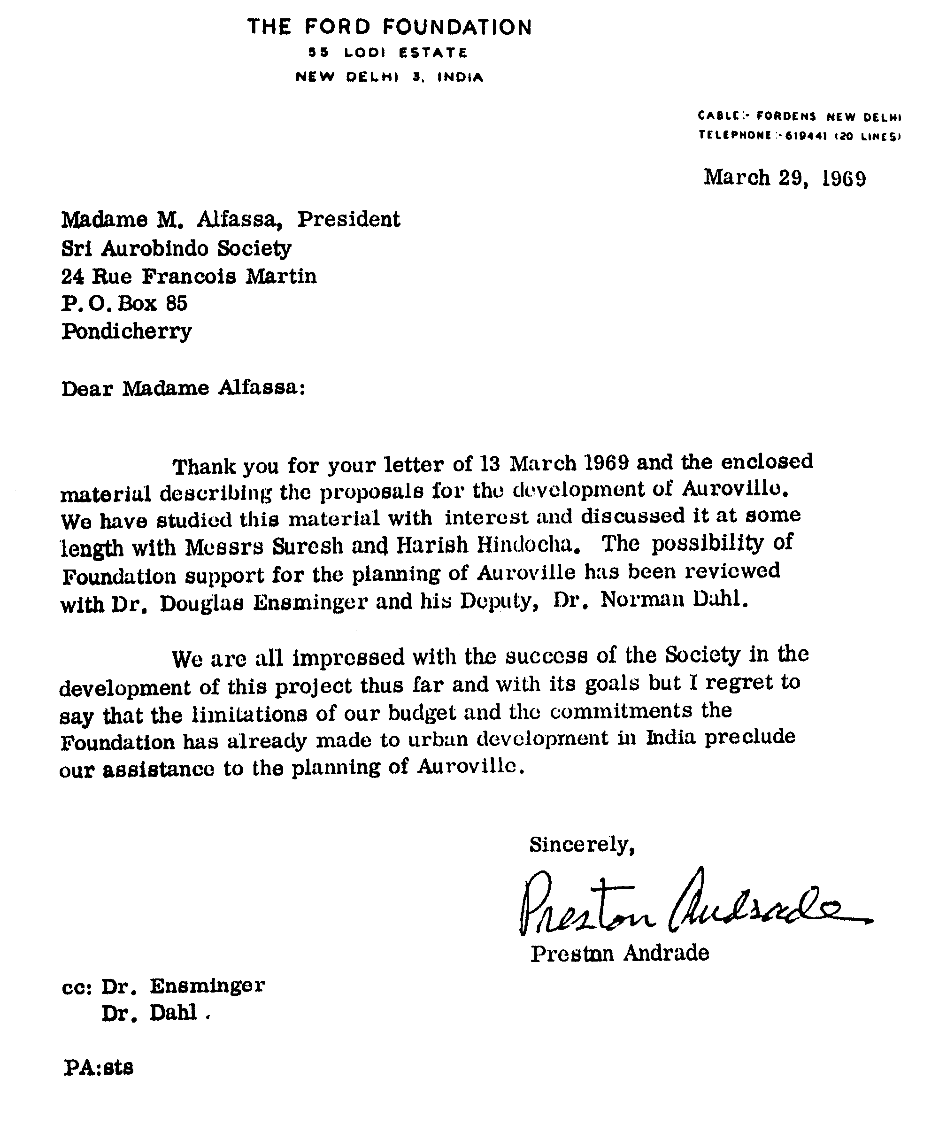

1. Suresh Hindocha is the nephew of Huta and the son of Laljibhai, the industrialist whom the Mother, in 1969, a crucial year, put in charge of Auroville's industrial zone. This is the same family that purchased the land for the Matrimandir. According to archive material, shortly before the Mother signed the document to be submitted to the Ford Foundation, she wrote “Yes” to Roger proposing “Suresh for the finances” and, regarding his father Laljibhai, “He would be at his place investigating industries for Auroville.” Two days later she added, “Yes, I prefer him [Suresh], there is a wealth. I am not mistaken.” That same day the Mother wrote this message, in French and in English, “Laljibhai Director of the organisation of the Industrial Zone of Auroville. Blessings”.